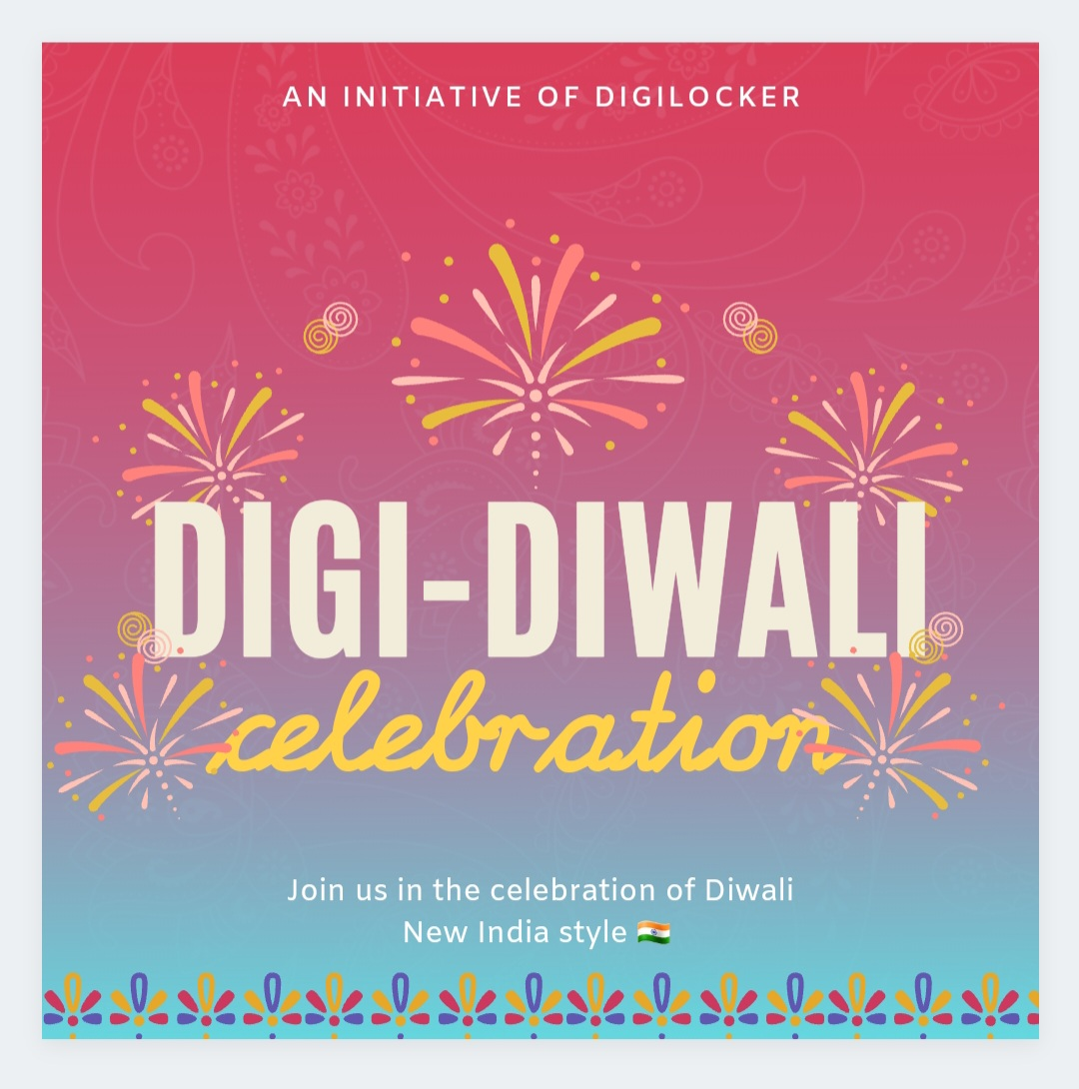

DAY -1

Digital cleaning

1. Article about how DigiLocker helps us be organized in our digital life.
2. Info-graphic about how DigiLocker fetches documents in real time.

DAY -2

Light in darkness

1. Article about how DigiLocker is transforming lives everyday.
2. Challenge to share story of how DigiLocker brightened your life for feature on blog.

(Special hashtag for this challenge)

Day – 3

Celebration of truth

1. Knowledge series – Bust the myth not the cracker
2. Concluding game – crossword puzzle or join the dots etc

Parents can post pictures of their children solving them as the last challenge.