Help & FAQ in DigiLocker

Proposed UI/UX Upgrades for DigiLocker Help Center & FAQ
Why Do Users Need the Help Center?
Users typically do not visit a Help Center casually; they arrive during moments of high friction, confusion, or urgency. The DigiLocker user base is highly diverse ranging from college students to elderly citizens with limited digital literacy. They rely on the Help Center when their primary goal (e.g., fetching a driving licence during a traffic stop, resetting a password, registering for an exam) is blocked.
The current Help Center architecture relies heavily on flat text and static documents, which fails to resolve these high stress use cases efficiently, leading to cognitive overload and increased support tickets.

- The Search for a Quick Fix (Information Retrieval)
Use Case: A user is trying to link their Aadhaar card but cannot figure out the steps. They navigate to the Help Center to find a quick answer.
- Where They Get Stuck : They are presented with a massive, flat list of FAQs requiring endless scrolling. When they do find a relevant guide, it is often a downloadable PDF, which is frustrating on a mobile network.
- Proposed Solutions:
  - Total Revamp of the FAQ Interface: Redesign the architecture to be search driven. Adding a prominent Search Bar exclusively for the FAQ allows users to bypass scrolling entirely. Implement a tabbed navigation structure (e.g., Most Popular → Registration → Security) to drastically improve "Findability."
  - Transition to HTML-Based Solutions: Eliminate downloadable PDF guides. Embed text directly into fast-loading, mobile-responsive HTML pages so users can access the solution without leaving the app environment.

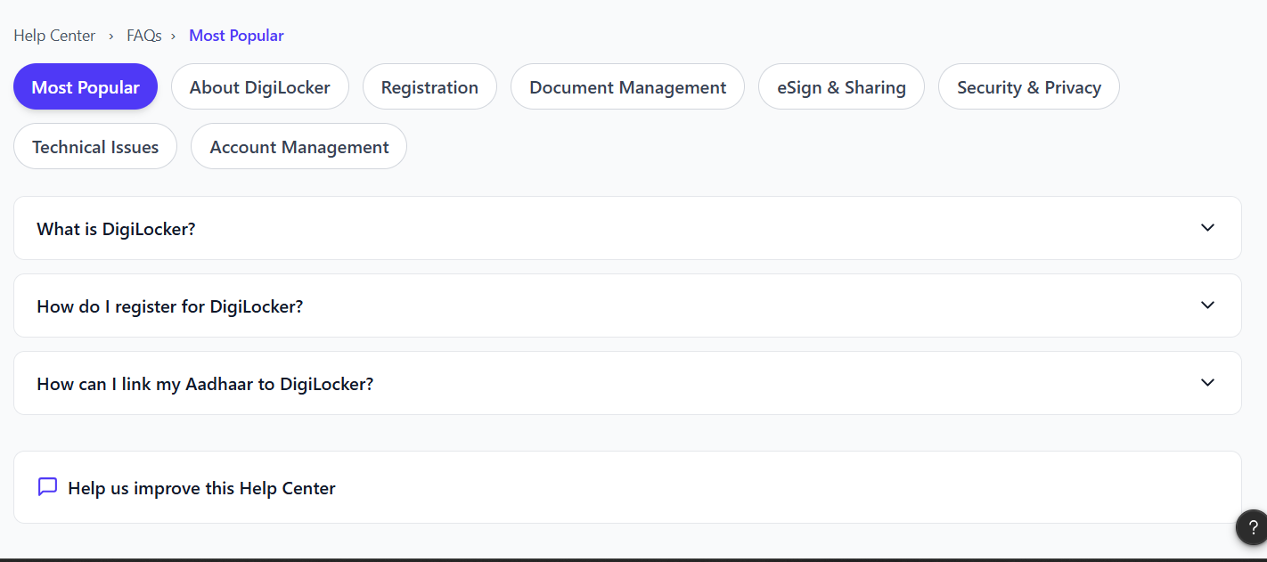

- Executing Complex Tasks (Comprehension)
Use Case: A user finds the text guide for creating an account, but the steps involve multiple screens and verifications that are difficult to visualize..
- Proposed Solution:
  - Visual & Multimedia Integration: Embed step-by-step photos and video tutorials directly into the Help Center for major workflows. Introduce a Video Directory categorized by Query Type | Reference Number | Issuing Department to bridge the gap between text and action.

- Handling the Unexpected (System Errors)
Use Case: A user tries to fetch their 10th marksheet and is suddenly hit with an arbitrary system error message (e.g., "Error 404-UID").
- Where They Get Stuck (Friction Point): The user is left guessing what the error means. They cannot find the exact error phrase in the generic FAQ list, leading to panic and support escalation.
- Proposed Solution:
  - "Search by Error Code" Functionality: Document specific error message codes within the Help Center and make them searchable.

- Use Case: An elderly user or a user with visual impairments is trying to read troubleshooting steps but struggles with the default app contrast and font size.
- Where They Get Stuck : The standard UI does not accommodate their physical needs, making self-help physically straining.
- Proposed Solution:
  - Dedicated Accessibility Settings: Explicitly provide toggles for accessibility features (text size, high contrast/dark mode) right inside the Help Center to ensure it remains inclusive for all demographics
- Use case: Once a user has navigated the Help Center, the journey must include data collection to measure success.
- User Feedback Loops: Add a "Was this helpful?" survey and a brief comment box at the bottom of every article. This data-driven approach highlights exactly which articles are solving problems and which require rewriting.
- Dynamic Promotional Banners: Utilize the Help Center's interface to display unobtrusive promotional banners. Since users are actively engaged with the app's ecosystem, it is valuable real estate to educate them on recent DigiLocker activities or feature updates.
6) Use Case: A user recently shared their DigiLocker documents with a third-party organization (like a bank). A week later, they want to revoke that access to protect their privacy.
- Where They Get Stuck (Friction Point): Users search the Help Center for "unshare" or "privacy," but struggle to map the written instructions to the actual "My Consent" dashboard deep in the app's settings.
- Proposed Solutions:
  - Deep-Linking from the Help Center: Upgrade the Help Center so it doesn't just tell the user what to do, but takes them there. For example, the article on "Revoking Document Consent" should have a direct UI button that says "Take me to Consent Settings."

