Help & FAQ in DigiLocker

Proposed UI/UX Upgrades for DigiLocker Help Center & FAQ
1. Transition from PDF to HTML-Based Solutions
- The Change: Eliminate downloadable PDF guides and replace them with embedded HTML text.
- The Impact: HTML pages load faster, are mobile-responsive, and are immediately accessible. This prevents users from having to download files just to find a quick solution, creating a much smoother, frictionless experience.
2. Visual & Multimedia Integration
- The Change: Embed step-by-step photos and video tutorials directly into the Help Center, specifically targeting major user queries like the registration process.
- The Impact: Currently, the lack of visual aids makes processes like account creation harder to follow. Implementing screen recordings and annotated screenshots will drastically reduce user confusion and support tickets.
- Video Directory: Introduce a structured table or directory for these video tutorials categorized by: Query Type | Reference Number | Issuing Department.
3. Total Revamp of the FAQ Interface
- The Change: Redesign the FAQ architecture to be search-driven and logically categorized.
- The Impact: Add a prominent Search Bar exclusively for the FAQ section so users can bypass scrolling. Implement a clear breadcrumb or tabbed navigation structure (e.g., Most Popular → About → Registration). This intuitive hierarchy helps users pinpoint exactly what they need in seconds.

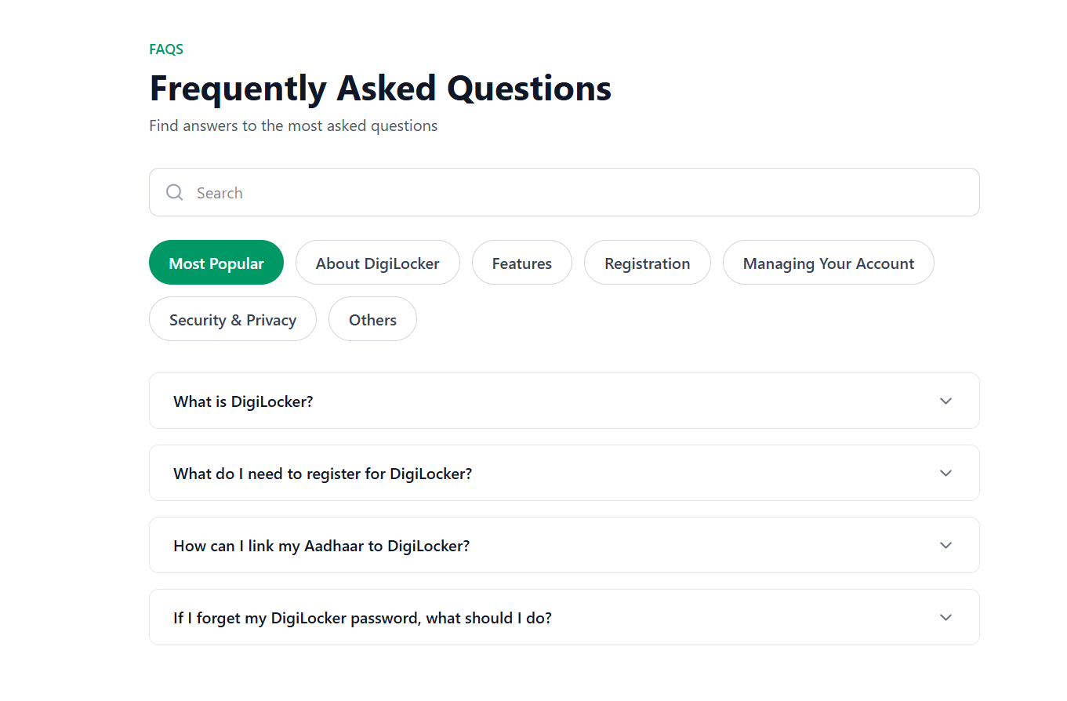

Drastically Improves "Findability" (Speed to Solution)
Reduces Cognitive Load (Makes it Easier to Use)
Scalability for Future Growth - The category-based structure is built to grow. You can add hundreds of new questions without cluttering the interface. They will simply be tucked away into their relevant categories, keeping the main view clean and organized.

4. "Search by Error Code"
- The Change: Document specific error message codes within the Help Center and make them searchable.
- The Impact: When a user encounters a system error, they are often left guessing. By allowing them to type the exact error code into the Help Center, they can instantly find the root cause and the specific resolution steps.

5. Dedicated Accessibility Settings
- The Change: Explicitly mention and provide toggles for accessibility features right inside the Help Center.
- The Impact: Include options to adjust text size and toggle color themes (like high contrast or dark mode). This ensures DigiLocker remains inclusive and usable for all demographics, including the elderly or visually impaired.

6. User Feedback Loops
- The Change: Add a "Was this helpful?" survey and a brief comment box at the bottom of every help article.
- The Impact: This direct feedback mechanism will highlight which articles are solving problems and which ones need rewriting, allowing for continuous, data-driven improvements to the support portal.
7. Dynamic Promotional Banners
- The Change: Utilize the Help Center's interface to display promotional banners for recent DigiLocker activities, new document issuers, or feature updates.
- The Impact: Since users visit the Help Center when they are actively engaged with the app, it serves as valuable real estate to educate them on new functionalities they might not be aware of.

