**Server Side Authentication**

**Summary:** Server side authentication is done to check is data entered on client side is verified or not. Whenever a user enters details in registration form then client side is being authenticated and after that when data passes to server then at that time one more authentication is performed on data which is on server side.

**Severity: Medium**

POST Request

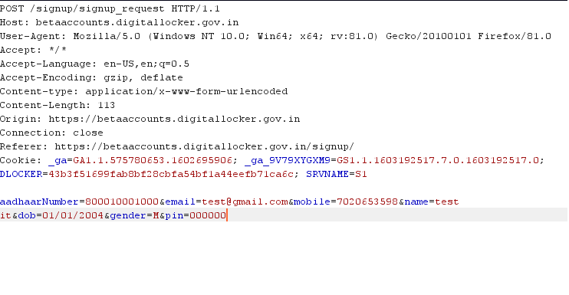

**Complexity: Easy**

**Steps: -**

Getting the post request by filling form

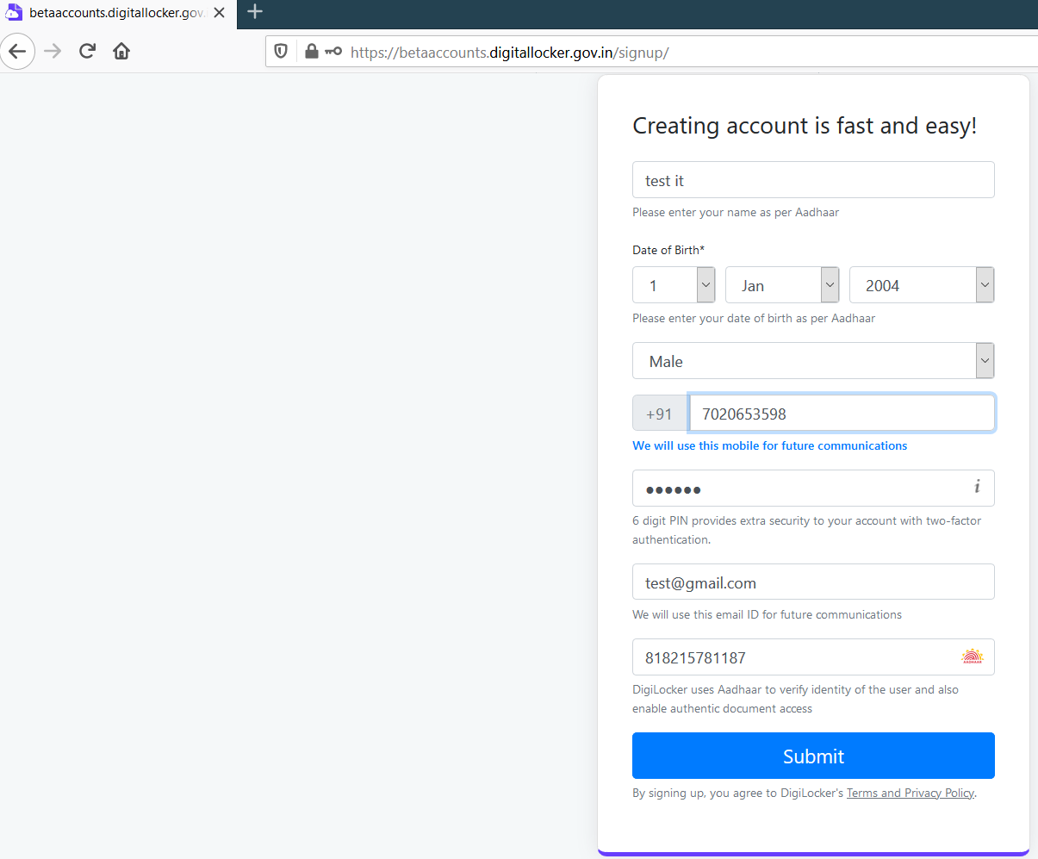

Now intercepting the request sending to repeater and changing the aadhar number

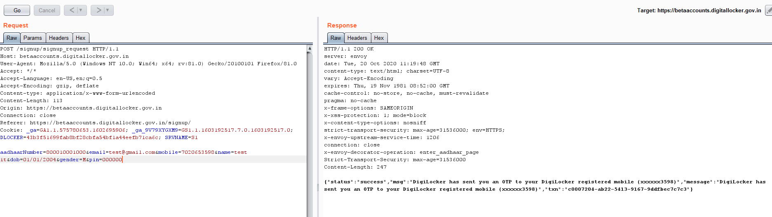

**Impact:** An attacker can used the data of other user which is not registered on site and can use his aadhar number to get access of all document and when main user tries to register on site then that user will unable to register on site

**Affected Page**

https://betaaccounts.digitallocker.gov.in/signup

**Recommendations:**

1. There should be a protection on the web application for limiting the user’s simultaneous requests.
2. There should be authentication on both server and client side

**Proof of Concept:**

F:\Hacking Progress\Internship\No rate limit pic\Server side issue\aadhar_success.png