ISSUE Found

.htaccess Information Leak

CWE ID

215

Description: -

htaccess files can be used to alter the configuration of the Apache Web Server software to enable/disable additional functionality and features that the Apache Web Server software has to offer.

Affected URL

URL https://apisetu.gov.in/public/console/marketplace/directory

Method GET

Evidence HTTP/1.1 200 OK

URL https://apisetu.gov.in/public/marketplace/api/.htaccess

Method GET

Evidence HTTP/1.1 200 OK

URL https://apisetu.gov.in/public/marketplace/api/js/js/.htaccess

Method GET

Evidence HTTP/1.1 200 OK

URL https://apisetu.gov.in/public/marketplace/api/js/.htaccess

Method GET

Evidence HTTP/1.1 200 OK

URL https://apisetu.gov.in/public/marketplace/api/js/js/js/.htaccess

Method GET

Evidence HTTP/1.1 200 OK

Proof of concept

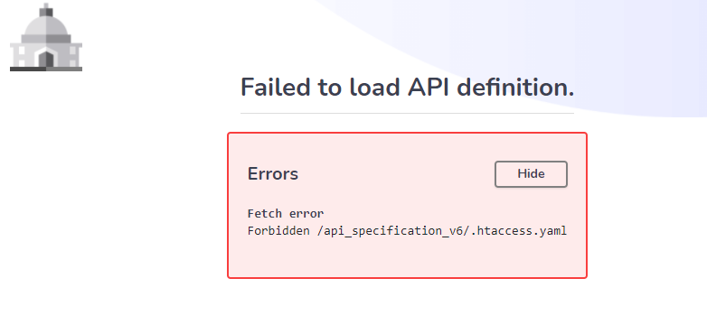

Here, the path for .htaccess file shown

Solution: -

Make sure that .htaccess file is not accessible

Reference: -

http://www.htaccess-guide.com/