**Support Form Test Report**

**Problem 1: - Accepting Input With random Origin Value**

Here, it is accepting the contact form details of form with normal and different both origin values

1. Normal Request and Response

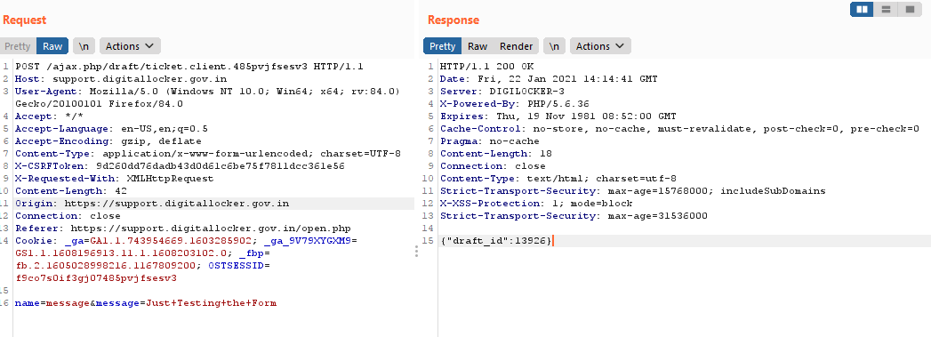

As you can see in left side request origin value is normal and in right side response it is showing **draft_id:13926** which means form is accepted

**Output**

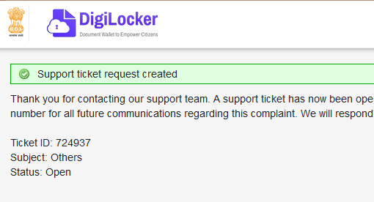

**With different value other than normal**

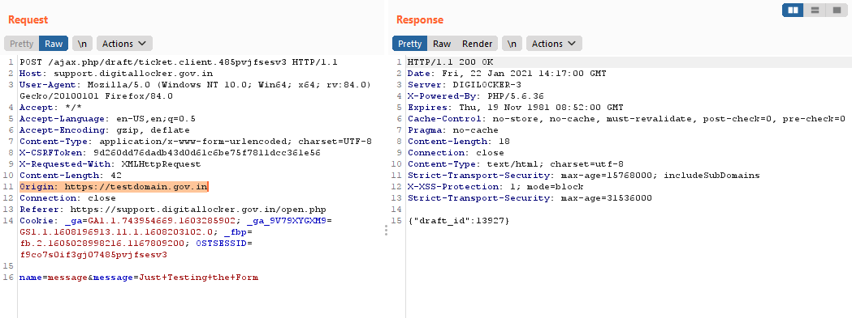

Above it can be seen that origin value is different and then also support form is accepting the data

**Impact: -**

It has no severe impact just it is a security misconfiguration problem

**Fix: -**

Just verify Origin value before submitting if valid Value then submit form otherwise no form to be submitted

**Problem2: - DOS Attack possibility (No rate Limit)**

There is possibility of DOS attack on support form

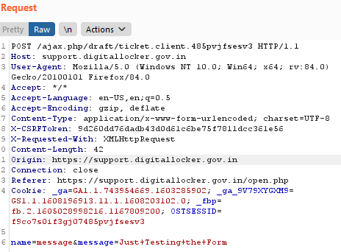

As shown above is the request generated after filling the support the form

Attack Demo

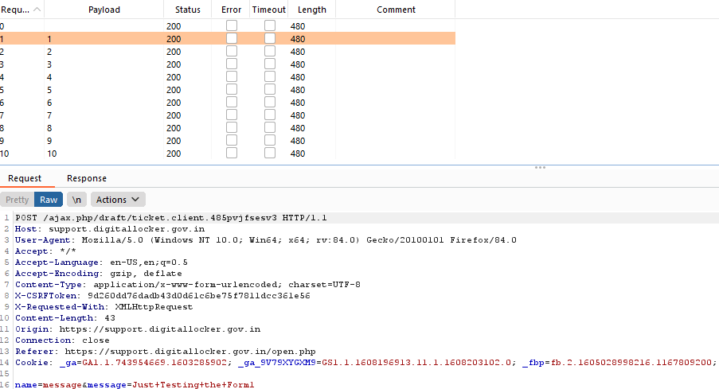

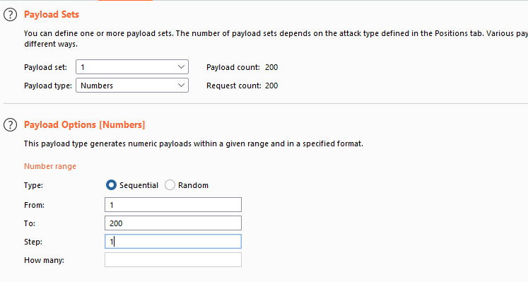

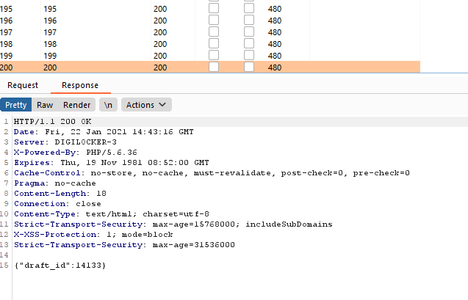

Here just for demo I have taken 200 limits here without any restriction we can send the support form request which can lead to DOS Attack to site and can takedown the site

**Impact: -**

Denial of service attack which can lead to take down the site

**Fix: -**

Give the rate limit for submitting the form ex: - There should be gap of intervals between submitting the form

Problem3: - Improper Input Validation

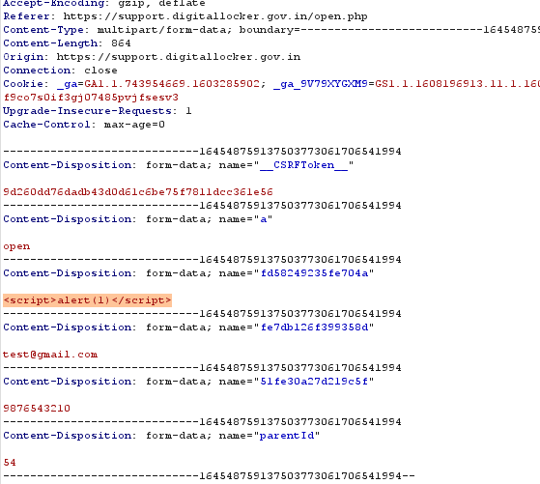

**Impact: -**

Lead to Cross Site Scripting Attack

**Fix: -**

Only Characters Value to Accepted and not any symbols.